Digital Logic Practical

Lab Report

Realization of Boolean Functions Using NAND Gate

Student:

Abhiroop Mukherjee

Teacher:

Prof. Surajeet Ghosh

Prof. Sekhar Mandal

Course:

Digital Logic Laboratory (CS351)

# Experiment 1(a)

## Objective

Realization Of AND, OR, NOR, XOR, XNOR Gate using NAND Gate

## Theory

1. The AND gate is a basic digital logic gate that implements logical conjunction
   * 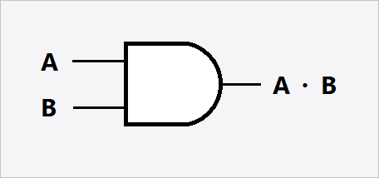Its Truth Table is as follows

|  |  |  |
| --- | --- | --- |
| A | B | Y = A.B |
| 0 | 0 | 0 |
| 0 | 1 | 0 |
| 1 | 0 | 0 |
| 1 | 1 | 1 |

Figure 1: Symbolic Representation of AND Gate

1. The OR gate is a digital logic gate that implements logical disjunction
   * 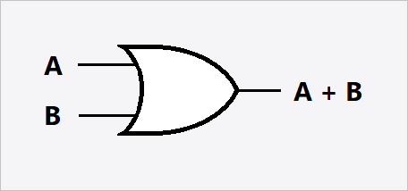Its Truth Table is as follows

Figure 2: Symbolic Representation of OR Gate

|  |  |  |
| --- | --- | --- |
| A | B | Y = A+B |
| 0 | 0 | 0 |
| 0 | 1 | 1 |
| 1 | 0 | 1 |
| 1 | 1 | 1 |

1. NOR is the result of the negation of the OR operator.
   * 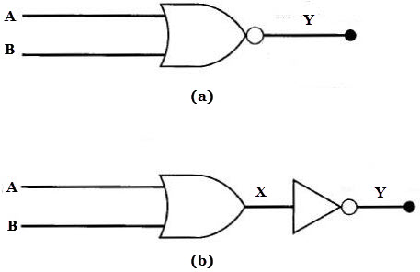Its Truth Table is as follows

|  |  |  |
| --- | --- | --- |
| A | B | Y = (A+B)’ |
| 0 | 0 | 1 |
| 0 | 1 | 0 |
| 1 | 0 | 0 |
| 1 | 1 | 0 |

Figure 3: Symbolic Representations of NOR Gate, Both Figure (a) and (b) are Equivalent

1. XOR is a digital logic gate that gives a true (1 or HIGH) output when the number of true inputs is odd.
   * The algebraic expressions or or all represent the XOR gate with inputs A and B.
   * 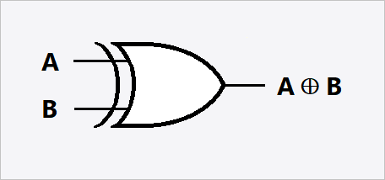Its Truth Table is as follows

Figure 4: Symbolic Representation of XOR Gate

|  |  |  |
| --- | --- | --- |
| A | B | Y =A |
| 0 | 0 | 0 |
| 0 | 1 | 1 |
| 1 | 0 | 1 |
| 1 | 1 | 0 |

1. The XNOR gate (sometimes ENOR, EXNOR or NXOR and pronounced as Exclusive NOR) is a digital logic gate whose function is the logical complement of the exclusive OR (XOR) gate.
   * 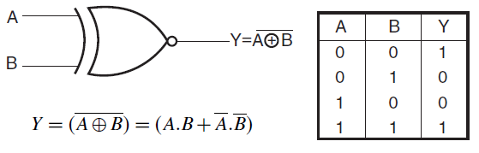Its Truth Table is as follows

Figure 5: Symbolic Representation of XNOR Gate

|  |  |  |
| --- | --- | --- |
| A | B | Y = |
| 0 | 0 | 0 |
| 0 | 1 | 1 |
| 1 | 0 | 1 |
| 1 | 1 | 0 |

1. A NAND gate (NOT-AND) is a logic gate which produces an output which is false only if all its inputs are true. thus, its output is complementing to that of an AND gate.
   * 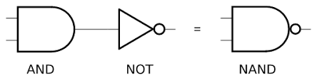Its Truth Table is as Follows

Figure 6: Symbolic Representations of NAND Gate

|  |  |  |
| --- | --- | --- |
| A | B | Y = |
| 0 | 0 | 0 |
| 0 | 1 | 1 |
| 1 | 0 | 1 |
| 1 | 1 | 0 |

## Circuit Diagrams

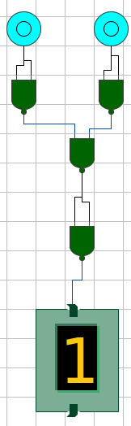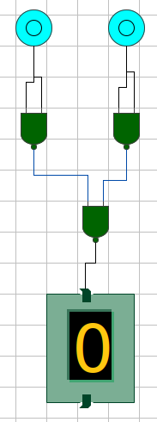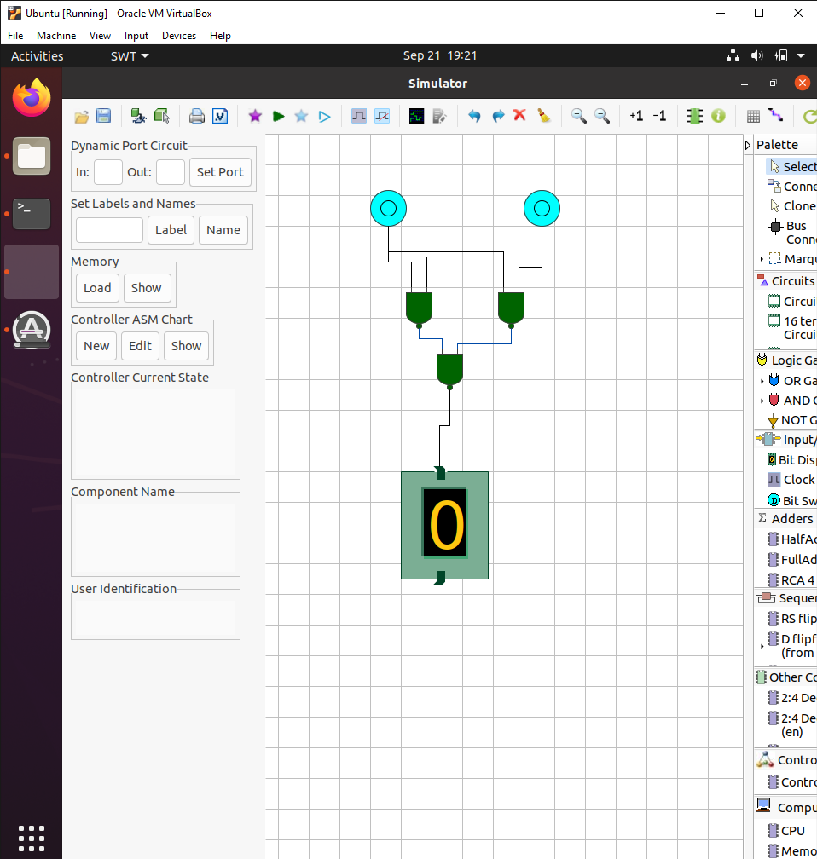 The Following Circuits were made for the following Gates (using NAND Gate)

Figure 9: NOR Gate using NAND Gates

Figure 8: OR Gate using NAND Gates

Figure 7: AND Gate using NAND Gates

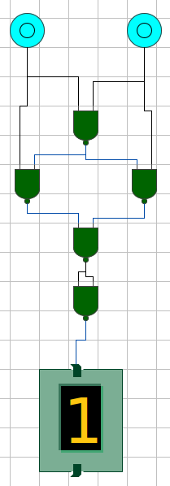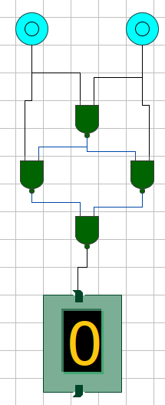

Figure 11: XNOR Gate using NAND Gates

Figure 10: XOR Gate using NAND Gates

## Input/Output

1. 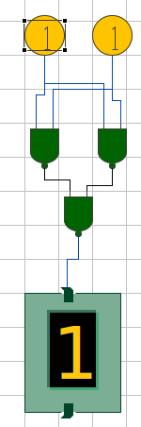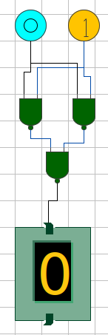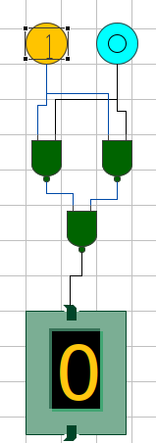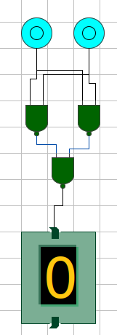AND Gate from NAND Gates

Figure 15: Output for 1 1

Figure 14: Output for 1 0

Figure 13: Output for 0 1

Figure 12: Output for 0 0

1. 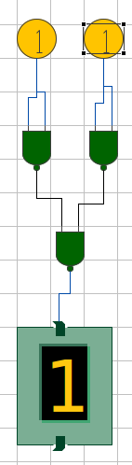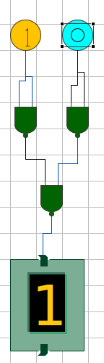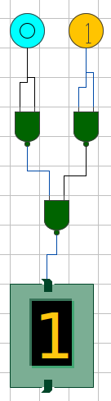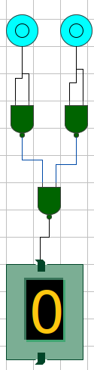OR Gate using NAND Gates

Figure 19: Output for 1 1

Figure 18: Output for 1 0

Figure 17: Output for 0 1

Figure 16: Output for 0 0

1. 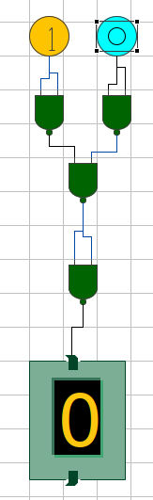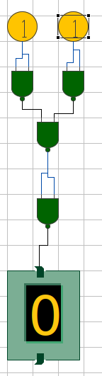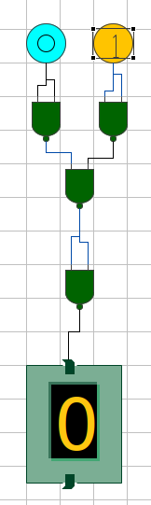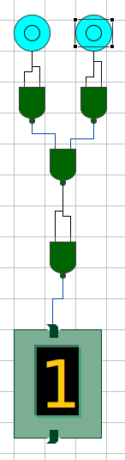NOR Gate using NAND Gates

Figure 23: Output for 1 1

Figure 21: Output for 0 1

Figure 20: Output for 0 0

Figure 22: Output for 1 0

1. 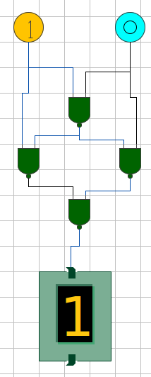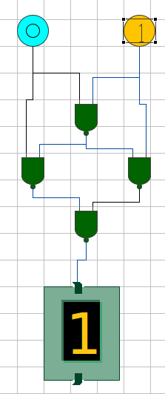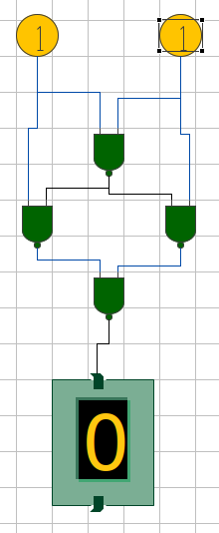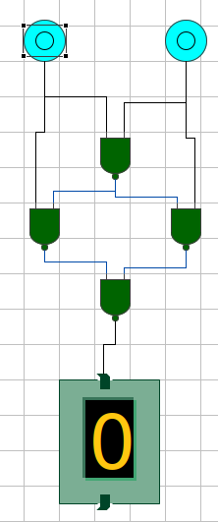XOR Gate using NAND Gates

Figure 24: Output for 0 0

Figure 27: Output for 1 1

Figure 26: Output for 1 0

Figure 25: Output for 0 1

1. 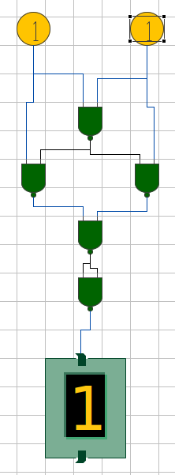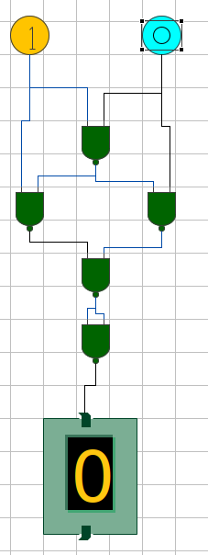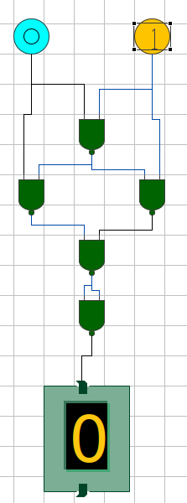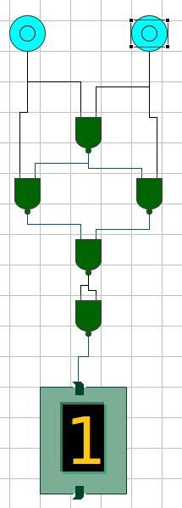XNOR Gate using NAND Gates

Figure31: Output for 1 1

Figure 30: Output for 1 0

Figure 29: Output for 0 1

Figure 28: Output for 0 0

# Experiment 1(b)

## Objective

Realization of Half Adder, Full Adder, Half Subtractor, and Full Subtractor using two input NAND Gates

## Theory

1. 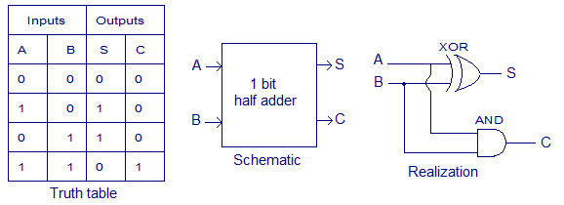Half adder is a combinational arithmetic circuit that adds two numbers and produces a sum bit (S) and carry bit (C) as the output.

Figure 2: Realization of Half Adder

|  |  |  |  |
| --- | --- | --- | --- |
| **Inputs** | | **Outputs** | |
| **x** | **y** | **C** | **S** |
| 0 | 0 | 0 | 0 |
| 0 | 1 | 0 | 1 |
| 1 | 0 | 0 | 1 |
| 1 | 1 | 1 | 0 |

* + From Truth Table, we observe that

1. Full Adder is the adder which adds three inputs and produces two outputs. The first two inputs are A and B and the third input is an input carry as C-IN. The output carry is designated as C-OUT and the normal output is designated as S which is SUM.

|  |  |  |  |  |
| --- | --- | --- | --- | --- |
| **Inputs** | | | **Outputs** | |
| **A** | **B** | **C - In** | **Sum** | **C - Out** |
| 0 | 0 | 0 | 0 | 0 |
| 0 | 0 | 1 | 1 | 0 |
| 0 | 1 | 0 | 1 | 0 |
| 0 | 1 | 1 | 0 | 1 |
| 1 | 0 | 0 | 1 | 0 |
| 1 | 0 | 1 | 0 | 1 |
| 1 | 1 | 0 | 0 | 1 |
| 1 | 1 | 1 | 1 | 1 |

* + 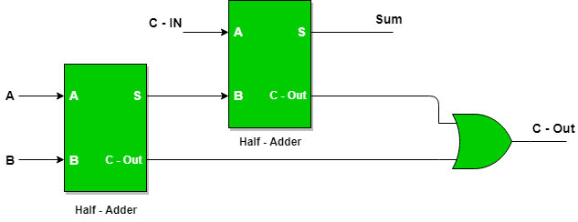As Full Adder is used in Binary Addition, we can cascade two Half Adders to form a Full Adder

Figure 3: Realization of Full Adder as the cascaded form of Two Half Adders

1. 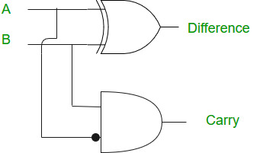A half subtractor is a logical circuit that performs a subtraction operation on two binary digits. The half subtractor produces a sum and a borrow bit for the next stage.

Figure 4: Realization of Half Subtractor

|  |  |  |  |
| --- | --- | --- | --- |
| **Input** | | **Output** | |
| **x** | **y** | **Borrow(B)** | **Difference(D)** |
| 0 | 0 | 0 | 0 |
| 0 | 1 | 1 | 1 |
| 1 | 0 | 0 | 1 |
| 1 | 1 | 0 | 0 |

* + From Truth Table, we observe that

1. A full subtractor is a combinational circuit that performs subtraction of two bits, one is minuend and other is subtrahend, considering borrow of the previous adjacent lower minuend bit.

|  |  |  |  |  |
| --- | --- | --- | --- | --- |
| **Inputs** | | | **Outputs** | |
| **A** | **B** | **B - In** | **Difference (D)** | **B - Out** |
| 0 | 0 | 0 | 0 | 0 |
| 0 | 0 | 1 | 1 | 1 |
| 0 | 1 | 0 | 1 | 1 |
| 0 | 1 | 1 | 0 | 1 |
| 1 | 0 | 0 | 1 | 0 |
| 1 | 0 | 1 | 0 | 0 |
| 1 | 1 | 0 | 0 | 0 |
| 1 | 1 | 1 | 1 | 1 |

* + 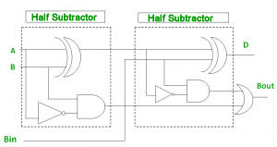As Full Subtractor is used in Binary Subtraction, we can cascade two Half Subtractor to form a Full Adder

Figure 5: Realization of Full Subtractor as the cascaded form of Two Half Subtractors

## Circuits



Figure 7: Full Adder Circuit. Here the Left Display is Sum(S) and right Display is Carry(C)

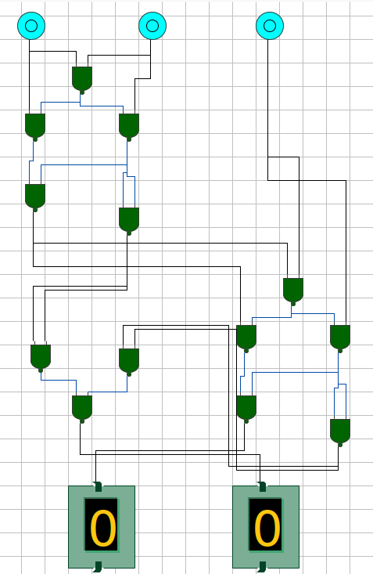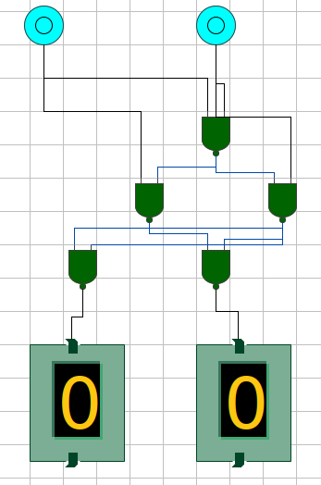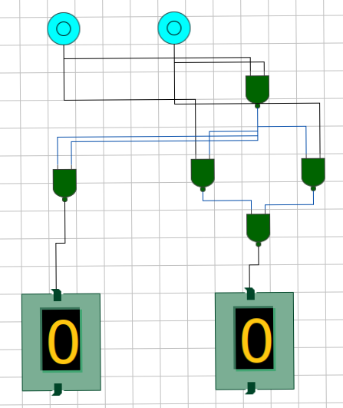



Figure 9: Full Subtractor Circuit. Here Left Display is Difference(D) and Right Display is B-out

Figure 6: Half Adder Circuit. The Left Display is Carry(C) and the Right Display is Sum(S)

## Outputs



Figure 8: Half Subtractor Circuit. Here the Left Display is Borrow(B) and Right Display is Difference(D)

1. Half Adder
   * This circuit take left input bit as ‘X’ and right input bit as ‘Y’, and outputs the sum ‘X+Y’ in right output display and Carry in left output display



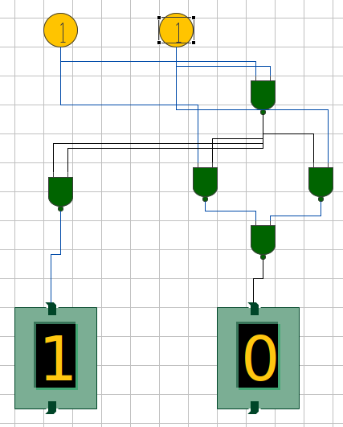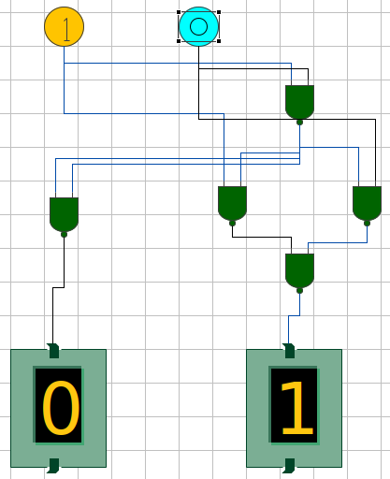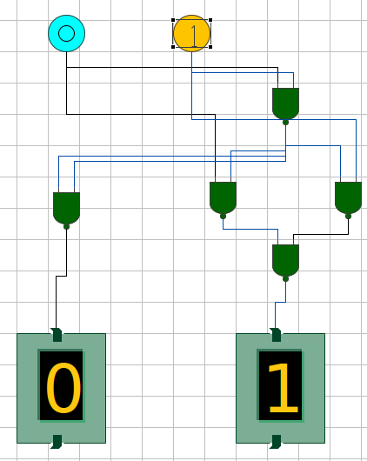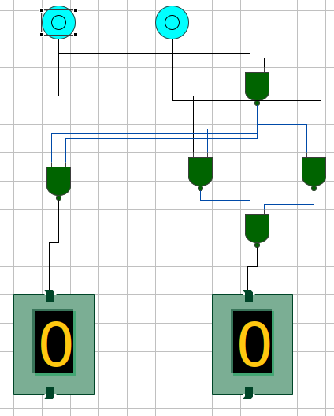

Figure 10: X=0, Y=0; C=0, S=0

Figure 13:X=1, Y=1; C=1, S=0

Figure 12:X=1, Y=0; C=0, S=1

Figure 11:X=0, Y=1; C=0, S=1

1. 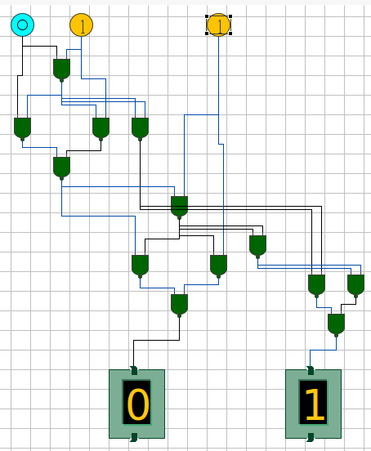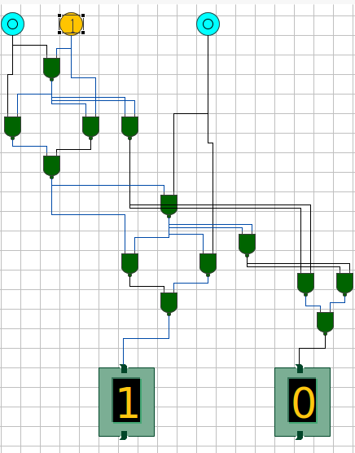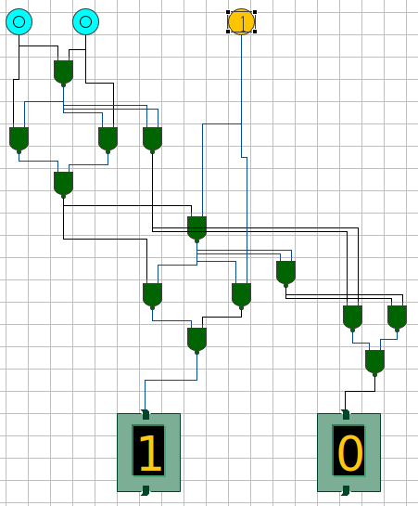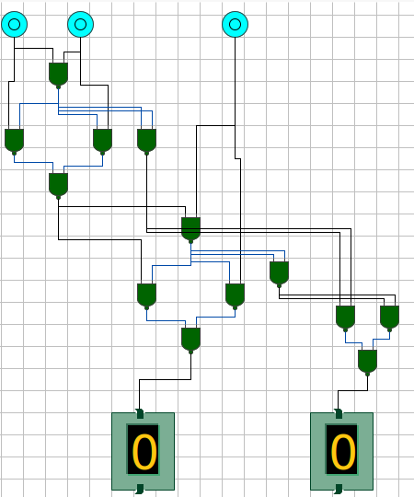Full Adder



Figure 17: X=0, Y=1, C-in=1; S=0, C-out=1

Figure 16: X=0, Y=1, C-in=0; S=1, C-out=0



Figure 14: X=0, Y=0, C-in=0; S=0, C-out=0

Figure 15: X=0, Y=0, C-in=1; S=1, C-out=0



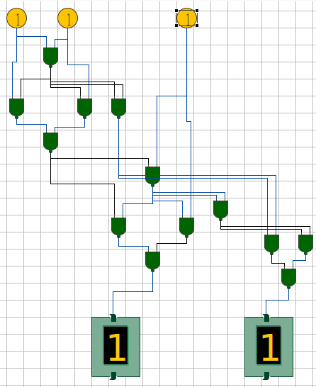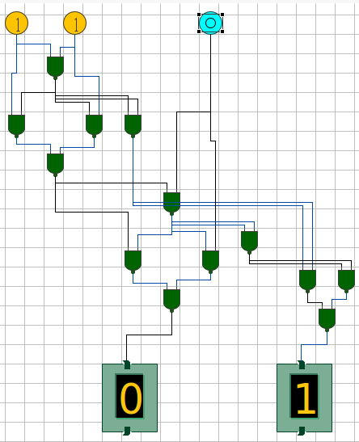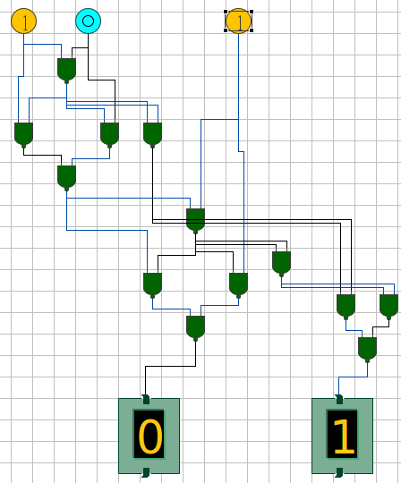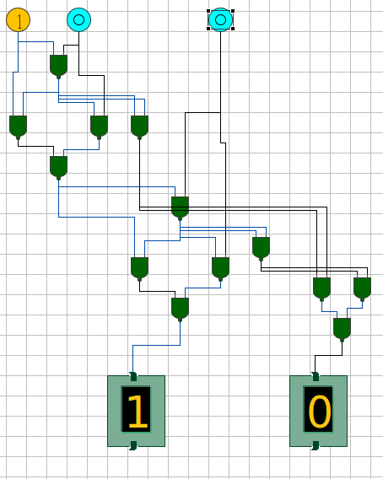



Figure 21: X=1, Y=1, C-in=1; S=1, C-out=1

Figure 20: X=1, Y=0, C-in=1; S=0, C-out=1

Figure 19: X=1, Y=0, C-in=1; S=0, C-out=1

Figure 18: X=1, Y=0, C-in=0; S=1, C-out=0

1. Half Subtractor
   * 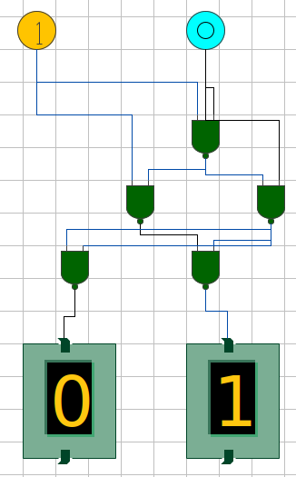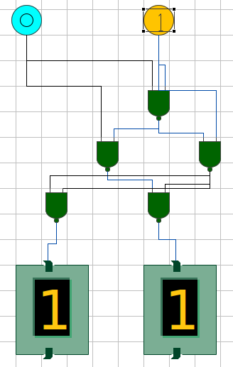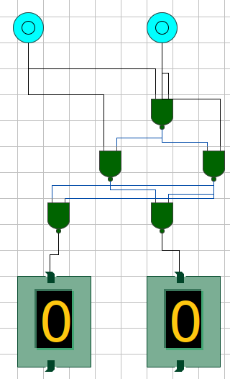This Circuit give Difference as X-Y

Figure 23: X=1, Y=0; B=0, D=1

Figure 23: X=0, Y=1; B=1, D=1

Figure 22: X=0, Y=0; B=0, D=0

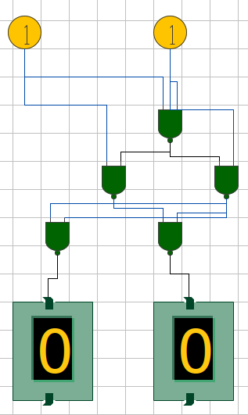



Figure 24: X=1, Y=1; B=0, D=0



1. Full Subtractor
   * This Circuit Give Difference as A - B - (B-in)

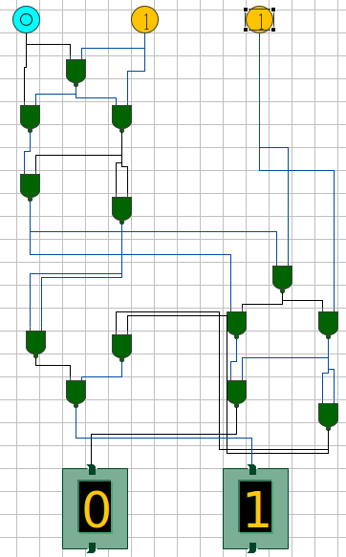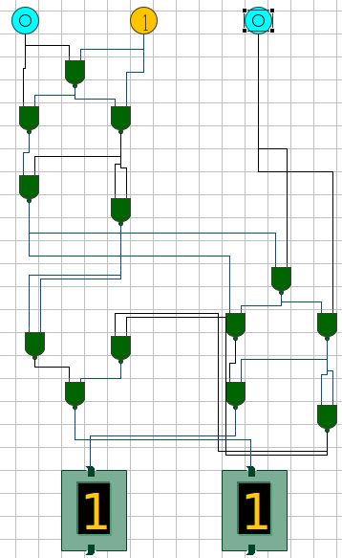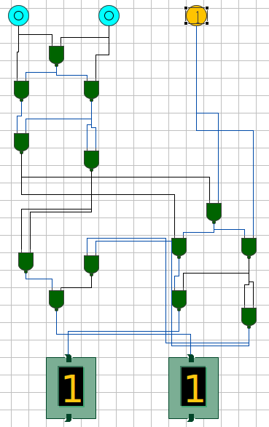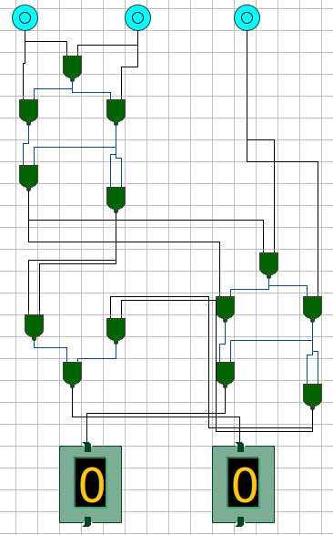



Figure 28: A=0, B=1, B-in=1; D=0, B-out=1

Figure 27: A=0, B=1, B-in=0; D=1, B-out=1

Figure 26: A=0, B=0, B-in=1; D=1, B-out=1

Figure 25: A=0, B=0, B-in=0; D=0, B-out=0



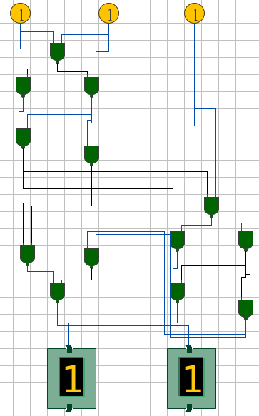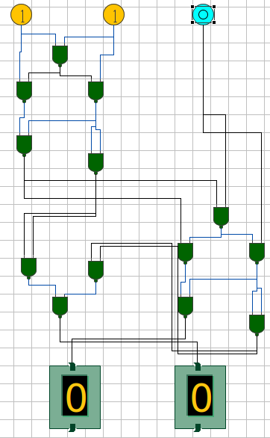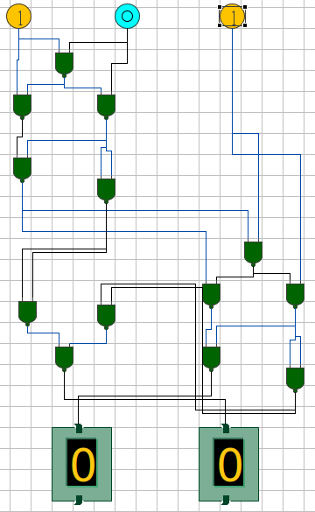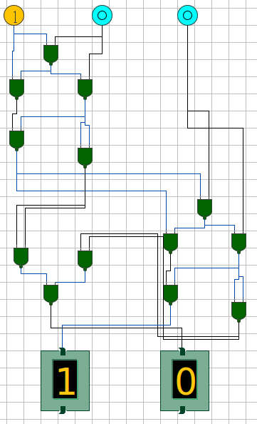



Figure 31: A=1, B=1, B-in=0; D=0, B-out=0

Figure 32: A=1, B=1, B-in=1; D=1, B-out=1

Figure 30: A=1, B=0, B-in=1; D=0, B-out=0

Figure 29: A=1, B=0, B-in=0; D=1, B-out=0

# Experiment 1(c)

## Objective

Realization of Half Adder, Full Adder, Half Subtractor, and Full Subtractor using two input NAND Gates and XOR gates

## Theory

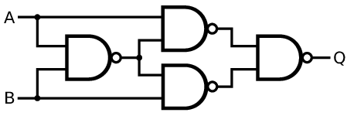 In every circuit made in Experiment 1(b), we can substitute the following arrangement of NAND Gates with XOR Gate, as they are logically equivalent.

Figure 1: Equivalent Circuit of XOR Gate made by NAND Gates

A

B

Q

Figure 2: XOR Gate

## Circuits

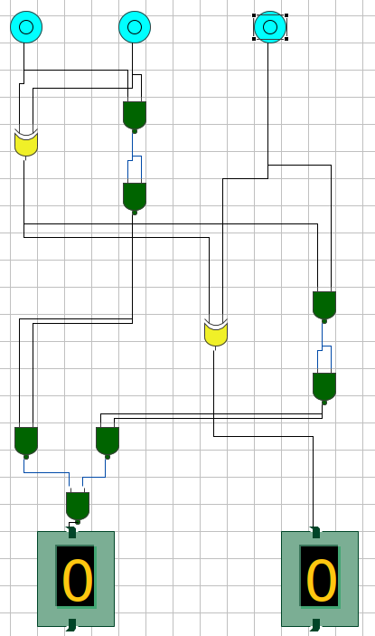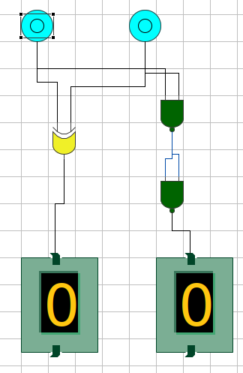



Figure 3: Full Adder Circuit



Figure 3: Half Adder Circuit

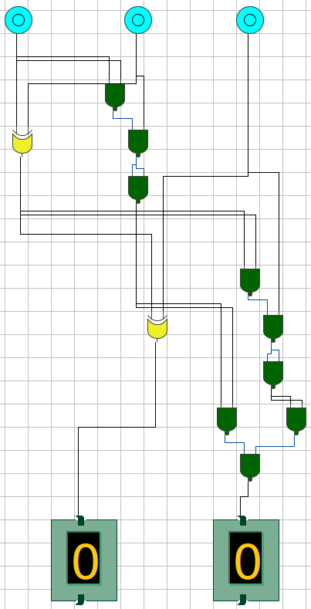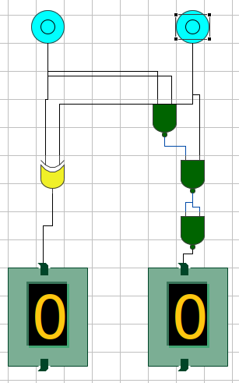



Figure 5: Full Subtractor Circuit



Figure 4: Half Subtractor Circuit

## Outputs

1. 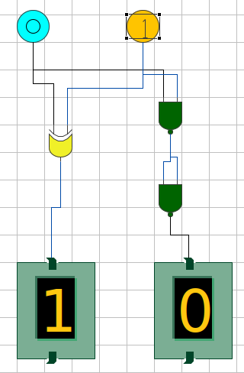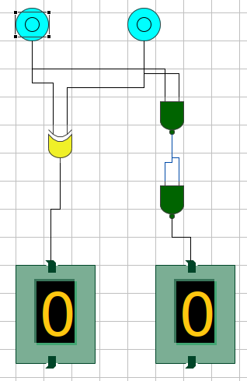Half Adder



Figure 6: X=0, Y=0; C=0, S=0

Figure 7:X=0, Y=1; C=0, S=1



1. 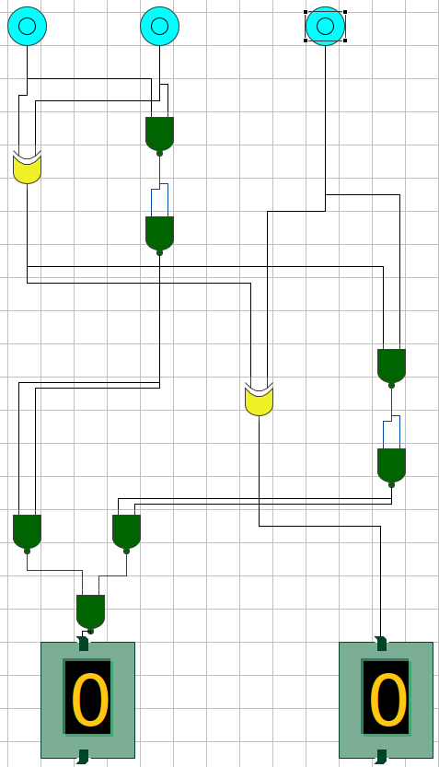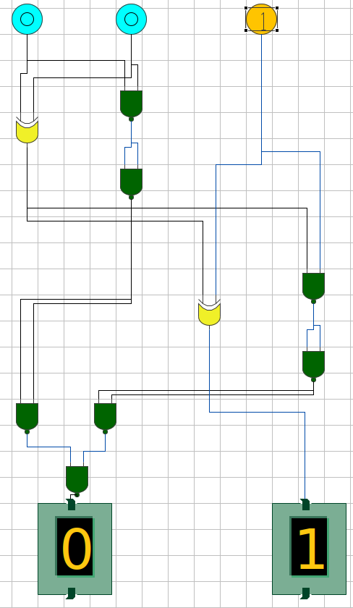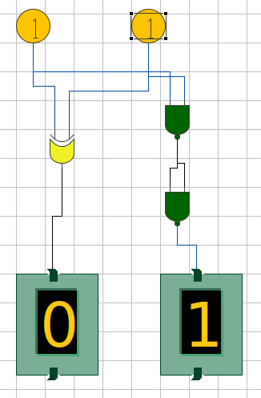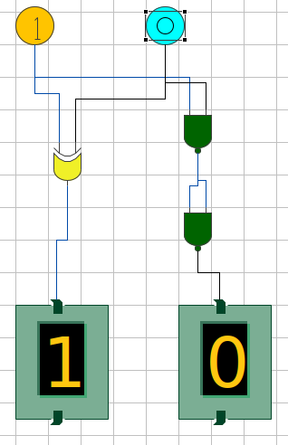Full Adder



Figure 10: X=0, Y=0, C-in=0; S=0, C-out=0

Figure 11: X=0, Y=0, C-in=1; S=1, C-out=0



Figure 9:X=1, Y=1; C=1, S=0

Figure 8:X=1, Y=0; C=0, S=1

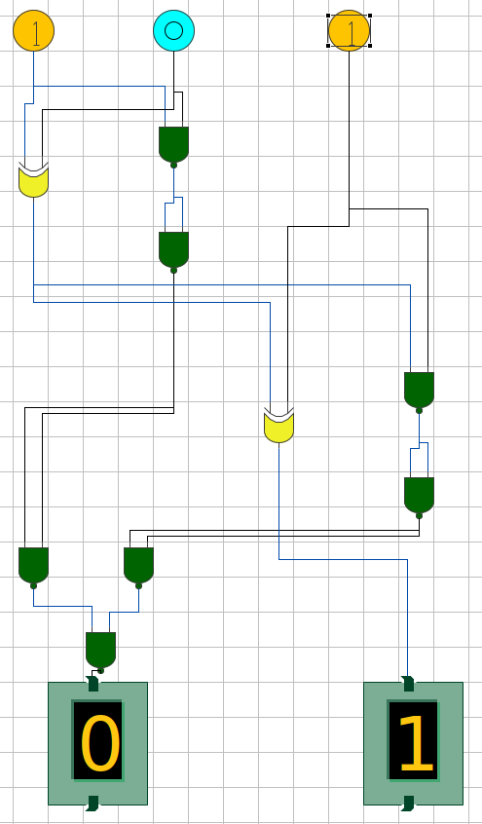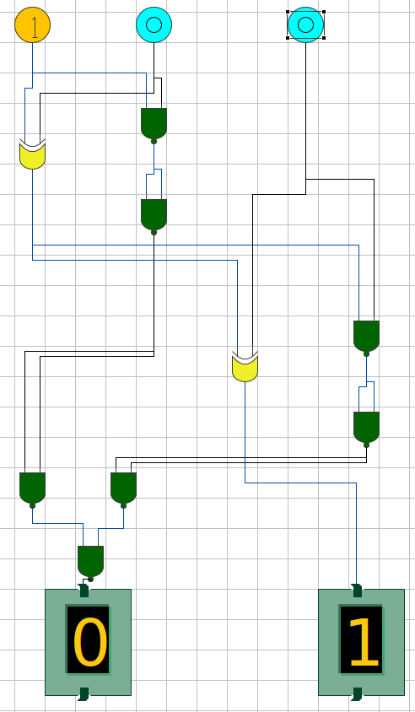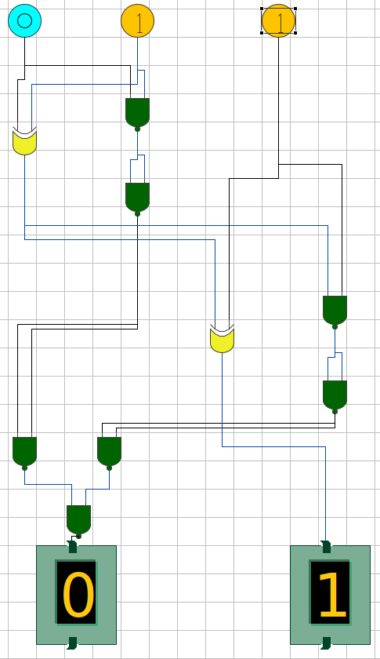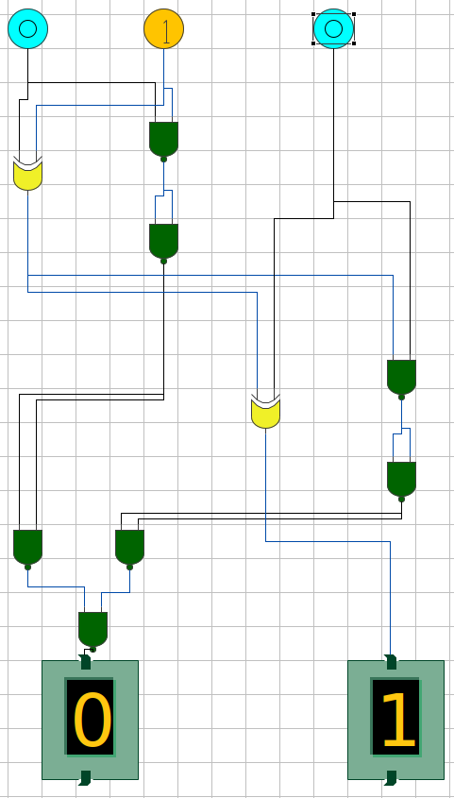



Figure 15: X=1, Y=0, C-in=1; S=0, C-out=1

Figure 14: X=1, Y=0, C-in=0; S=1, C-out=0

Figure 12: X=0, Y=1, C-in=0; S=1, C-out=0

Figure 13: X=0, Y=1, C-in=1; S=0, C-out=1

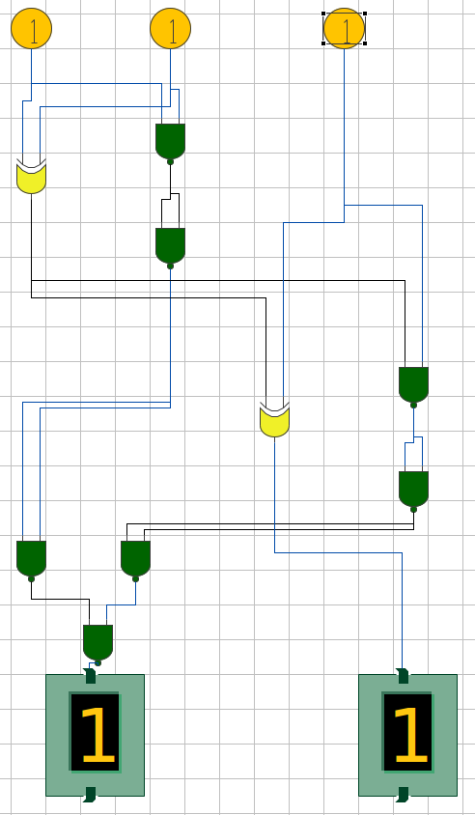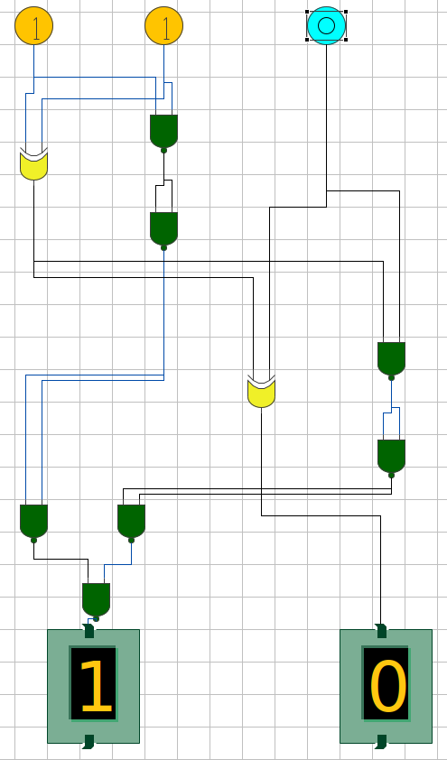

Figure 16: X=1, Y=0, C-in=1; S=0, C-out=1

Figure 17: X=1, Y=1, C-in=1; S=1, C-out=1



1. Half Subtractor
   * This Circuit give Difference as X-Y

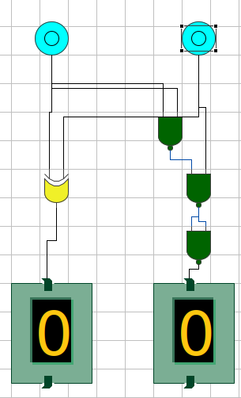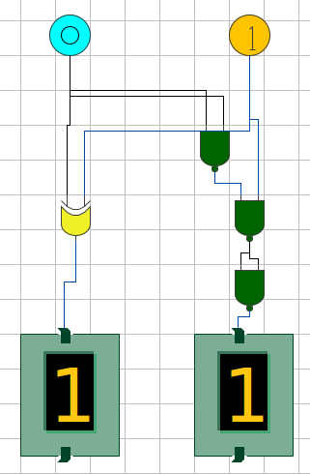



Figure 18: X=0, Y=0; B=0, D=0

Figure 19: X=0, Y=1; B=1, D=1



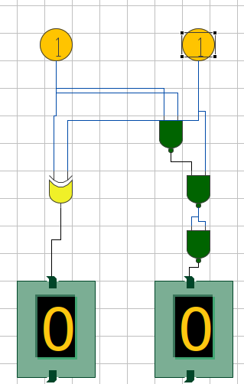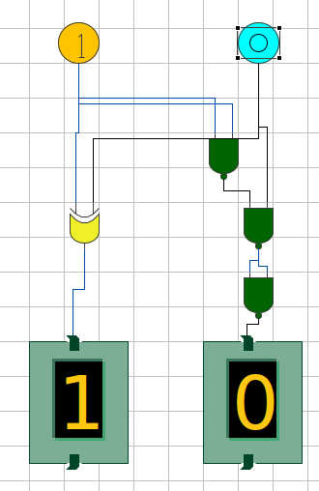



Figure 20: X=1, Y=0; B=0, D=1

Figure 21: X=1, Y=1; B=0, D=0

1. Full Subtractor
   * 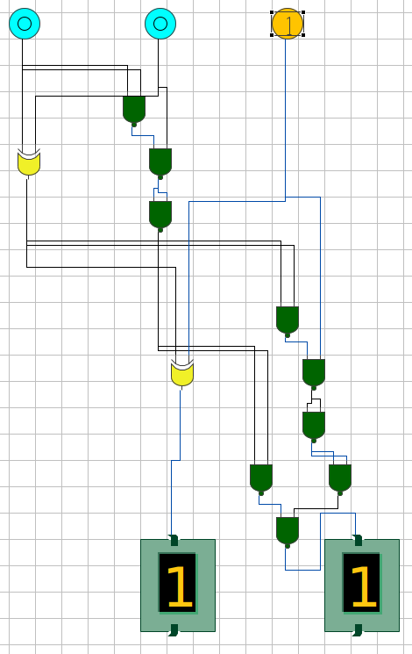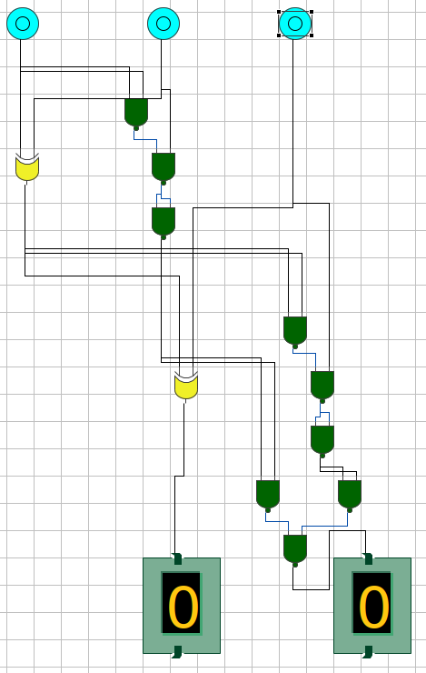This Circuit Give Difference as A - B - (B-in)

Figure 23: A=0, B=0, B-in=1; D=1, B-out=1



Figure 22: A=0, B=0, B-in=0; D=0, B-out=0

Figure 25: A=0, B=1, B-in=1; D=0, B-out=1

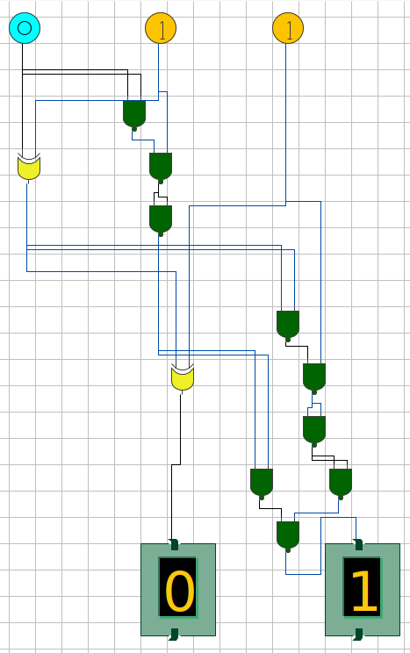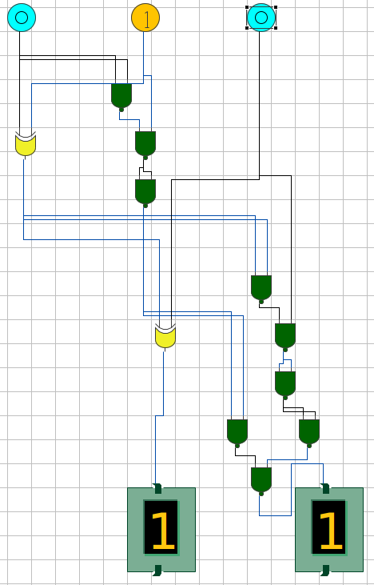



Figure 24: A=0, B=1, B-in=0; D=1, B-out=1



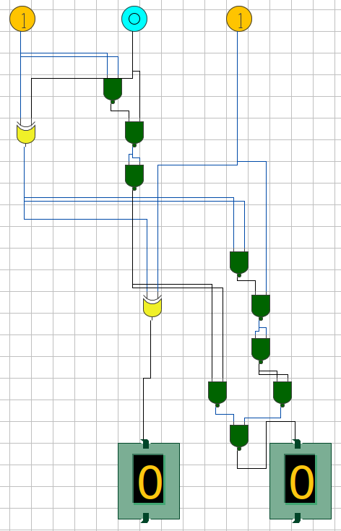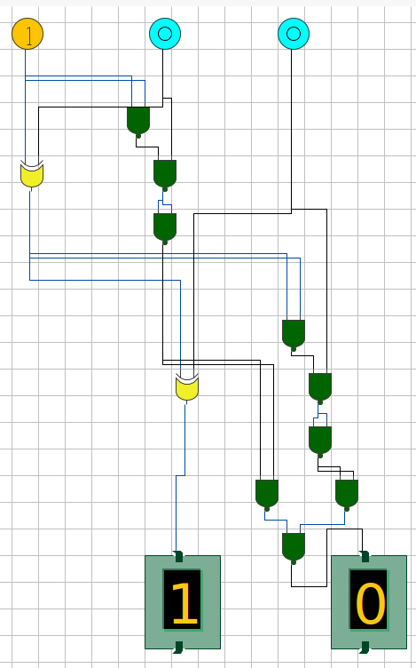

Figure 27: A=1, B=0, B-in=1; D=0, B-out=0

Figure 26: A=1, B=0, B-in=0; D=1, B-out=0



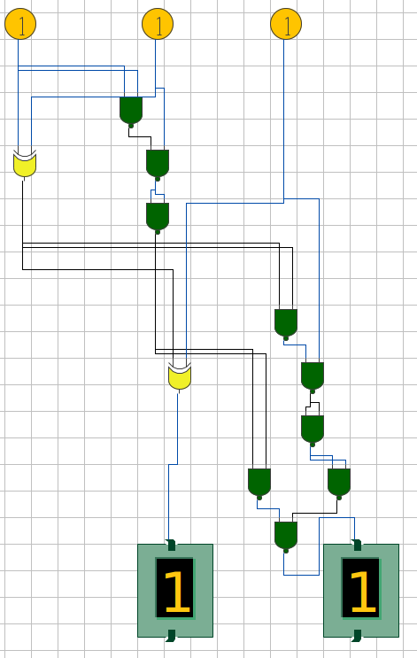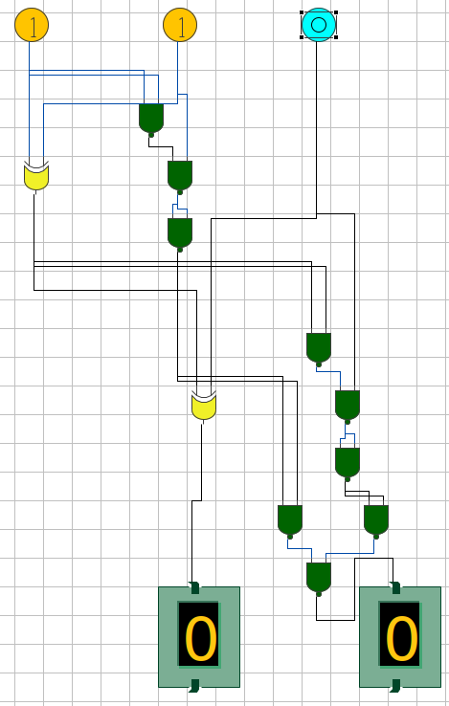



Figure 31: A=1, B=1, B-in=0; D=0, B-out=0

Figure 32: A=1, B=1, B-in=1; D=1, B-out=1

# Experiment 2

## Objective

Implement BCD-to-Gray code convertor using minimum numbers of two inputs NAND gates.

## Theory

* Following Truth Table Exists for BCD to Gray Conversion

|  |  |  |  |  |  |  |  |  |
| --- | --- | --- | --- | --- | --- | --- | --- | --- |
| **Decimal** | **BCD Input** | | | | **Gray Code Output** | | | |
|  | **B3** | **B2** | **B1** | **B0** | **D3** | **D2** | **D1** | **D0** |
| **0** | 0 | 0 | 0 | 0 | 0 | 0 | 0 | 0 |
| **1** | 0 | 0 | 0 | 1 | 0 | 0 | 0 | 1 |
| **2** | 0 | 0 | 1 | 0 | 0 | 0 | 1 | 1 |
| **3** | 0 | 0 | 1 | 1 | 0 | 0 | 1 | 0 |
| **4** | 0 | 1 | 0 | 0 | 0 | 1 | 1 | 0 |
| **5** | 0 | 1 | 0 | 1 | 0 | 1 | 1 | 1 |
| **6** | 0 | 1 | 1 | 0 | 0 | 1 | 0 | 1 |
| **7** | 0 | 1 | 1 | 1 | 0 | 1 | 0 | 0 |
| **8** | 1 | 0 | 0 | 0 | 1 | 1 | 0 | 0 |
| **9** | 1 | 0 | 0 | 1 | 1 | 1 | 0 | 1 |

* Using this Truth Table, we can write that
  + D3 = ∑ (8,9) + ∑d (10,11,12,13,14,15)
  + D2 = ∑ (4,5,6,7,8,9) + ∑d (10,11,12,13,14,15)
  + D1 = ∑ (2,3,4,5) + ∑d (10,11,12,13,14,15)
  + D0 = ∑ (1,2,5,6,9) + ∑d (10,11,12,13,14,15)
* Following K-Maps are made by these expression

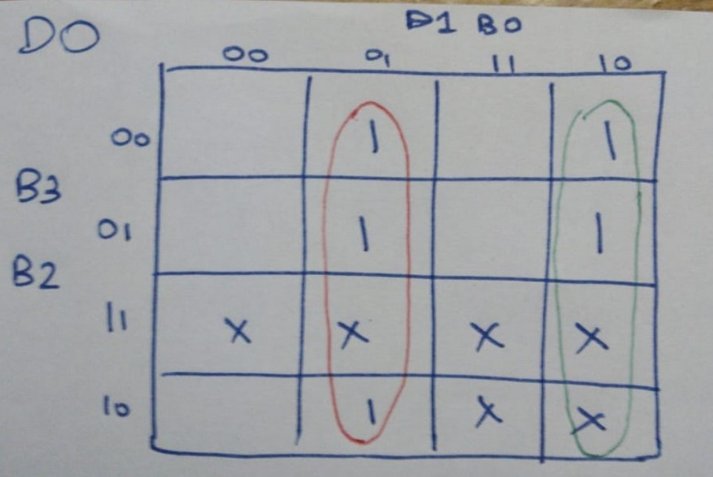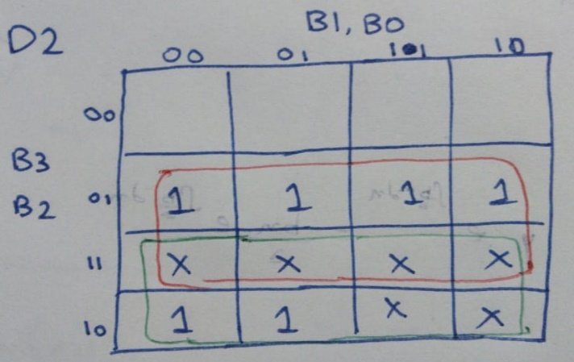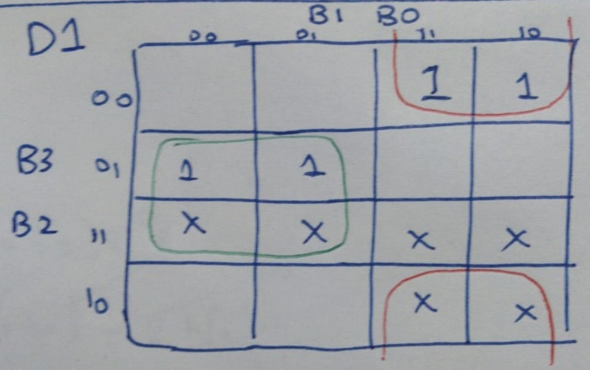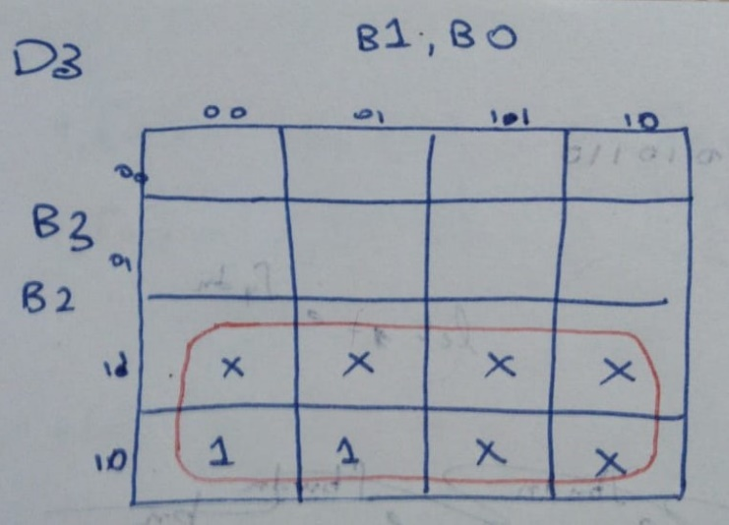

Figure 4: K-Map for D0

Figure 2: K-Map for D2

Figure 3: K-Map for D1

Figure 1: K-Map for D3

* From these K-Maps, we find the following minterms
  + D3 = B3
  + D2 = B2 + B3
  + D1 = B2’.B1 + B2.B1’ = B2 XOR B1
  + D0 = B1’.B0 + B1.B0’ = B1 XOR B0

## Circuit

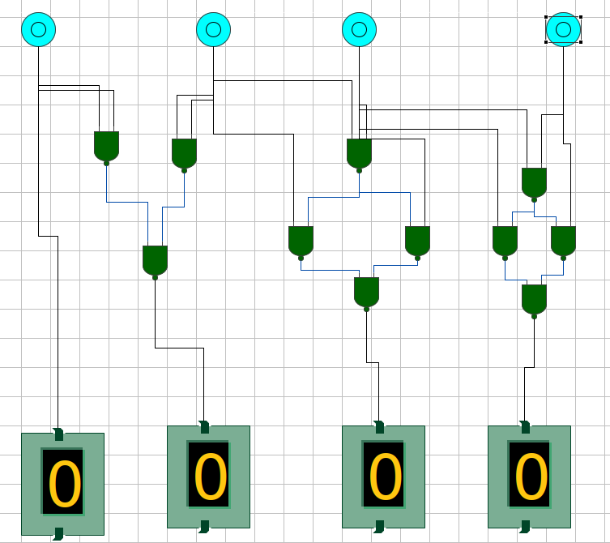 Based on the minterms found, following circuit was made



Figure 5: BCD-to-GRAY Code Converter Circuit

## Outputs

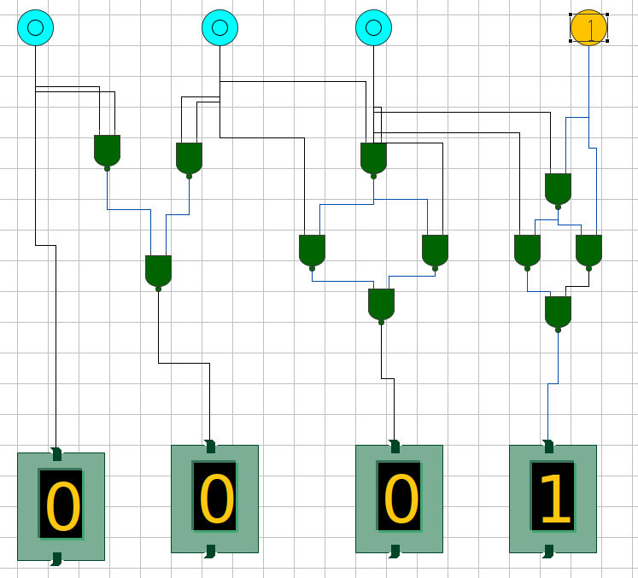



Figure 7: Output for Decimal 1

Figure 6: Output for Decimal 0

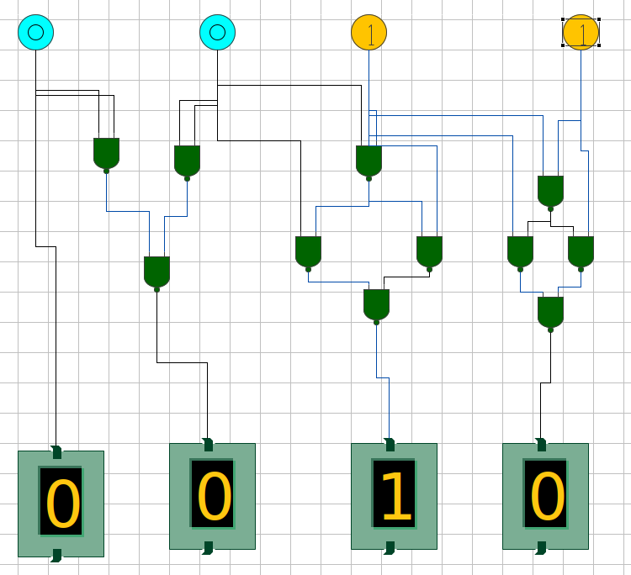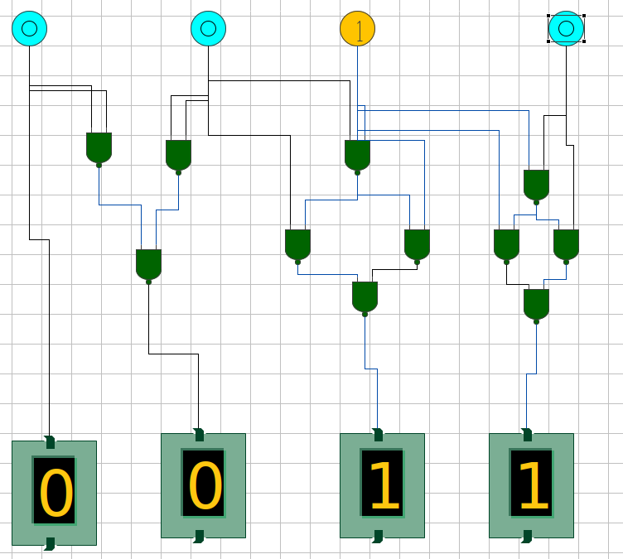



Figure 9: Output for Decimal 3

Figure 8: Output for Decimal 2

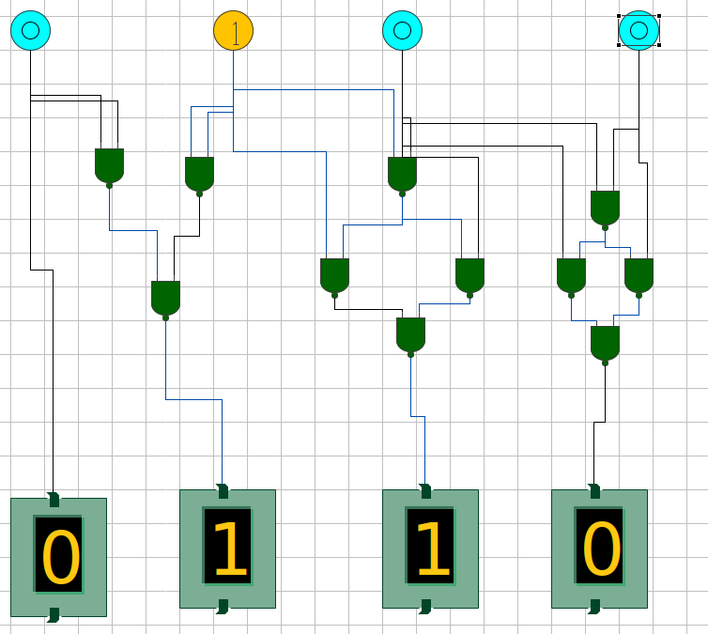



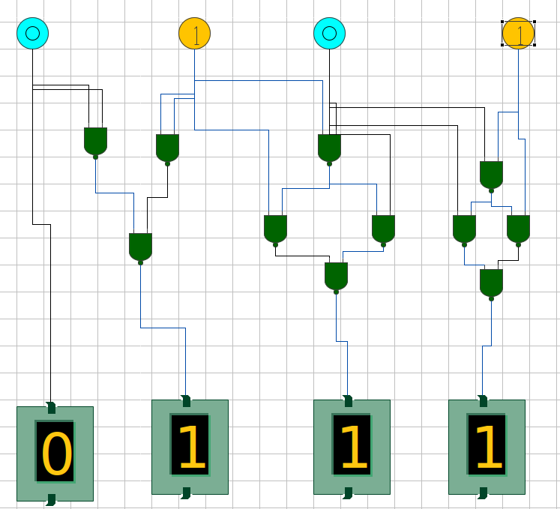



Figure 11: Output for Decimal 5

Figure 10: Output for Decimal 4

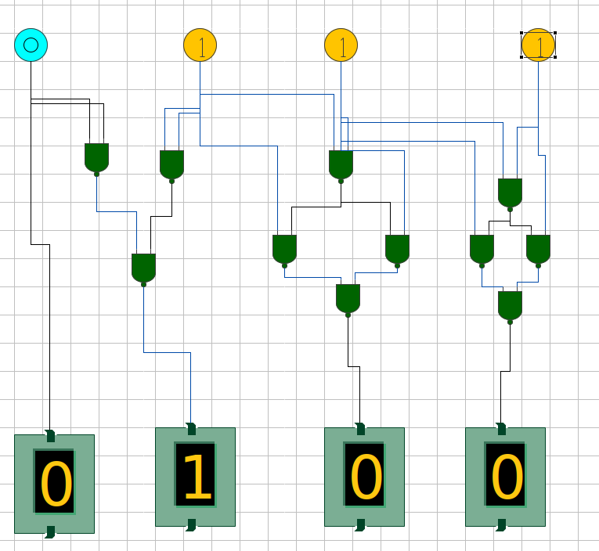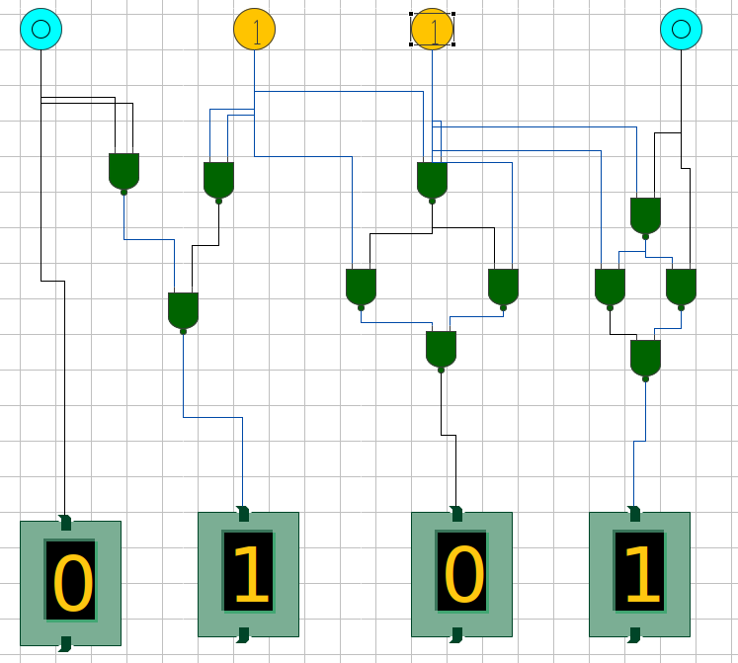



Figure 13: Output for Decimal 7

Figure 12: Output for Decimal 6

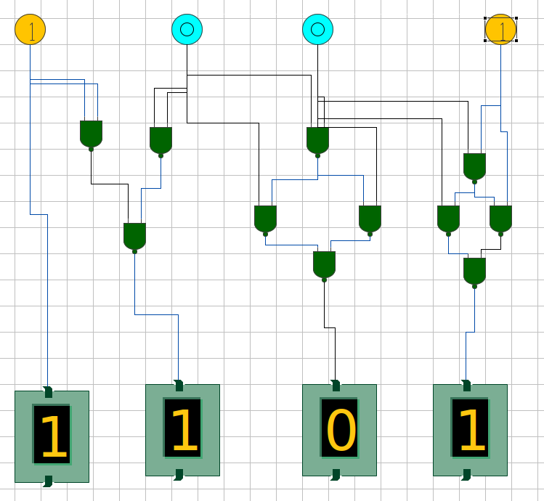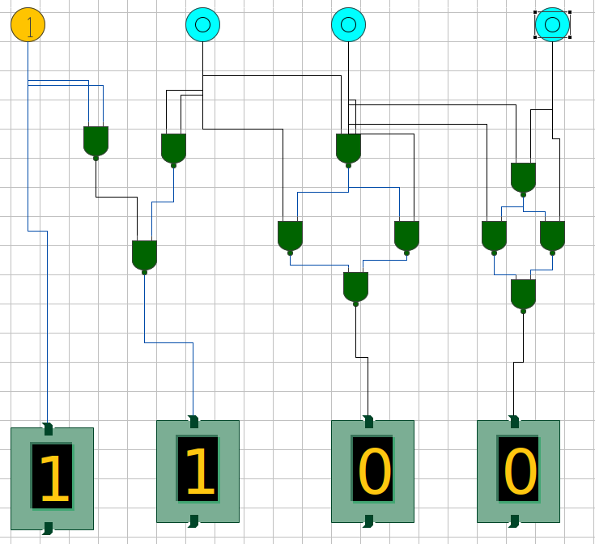



Figure 14: Output for Decimal 9

Figure 13: Output for Decimal 8